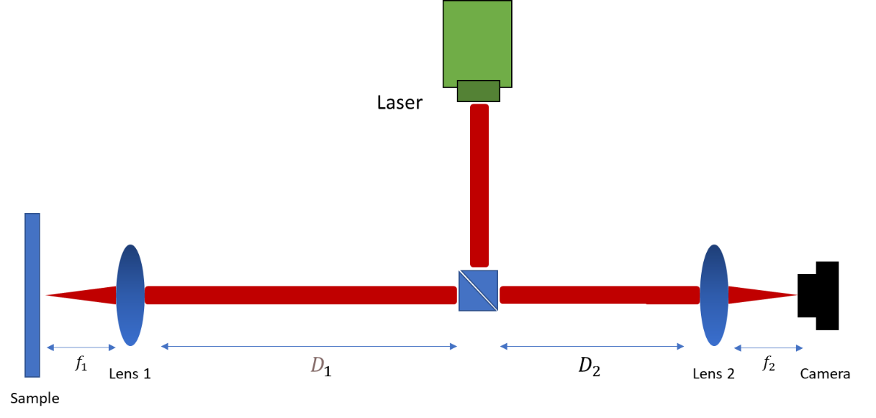

Figure 1: Simplified Schematic of the optical path used in the simulation.

**Simulation of the experimental system**

We simulate the experimental work in an analytical approach. The details are as follows: We model the initial beam as Gaussian wave due to the nature of the laser source.

Electric field amplitude of a Gaussian beam (with a large Rayleigh length) can be written as follows [1]:

|  |  |  |
| --- | --- | --- |
|  | $$U_{0}\left(x,y,z=0\right)= E_{0}e^{-\frac{r^{2}}{w_{0}^{2}}}$$ | (1) |

Here, $+z$ is the direction of propagation, $x$ and are perpendicular to the $z$ axis in the standard convention,, and $w_{0}$ is the beam waist. We ignore the effect of the beam-splitter and the flat mirrors (on the optical path) on the laser. The effect of the propagation of the wave over a distance of $D_{1}$ in free space can be calculated by using the Rayleigh-Sommerfeld integral  [1].

|  |  |  |
| --- | --- | --- |
|  | $$U\left(x,y,z=D_{1}\right)=\frac{1}{iλ}\iint{U_{0}(x^{'},y^{'},z=0)\frac{D_{1}e^{ikr}}{r^{2}}dx'dy'}$$ | (2) |

where $r=\sqrt{{(x-x^{'})}^{2}+{(y-y^{'})}^{2}+z^{2}}$, $λ$ =532 nm is the wavelength of light.

The wave arrives at the front surface of lens #1 after this propagation. The modification of the incoming wavefront by a lens with a focal length of $f_{1}$ is given as follows  [1]:

|  |  |  |
| --- | --- | --- |
|  | $$L_{1}\left(x,y\right)=e^{\frac{ik(x^{2}+y^{2})}{2f_{1} }}$$ | (3) |

Consequently, right after lens #1, the wave has the form:

$$U_{1}\left(x,y\right)={U(x,y)L}_{1}(x,y)$$

After lens #1, the wave propagates by a distance of in free space, then it gets reflected by the sample, then it propagates back to lens #1 by a distance of. We assume that the sample is a perfect flat mirror such that it does not alter the shape of the wave as it reflects the wave at the focal point of lens #1. Thus, we skip that step and simply propagate the wave,, after lens #1 by a distance of 2.

This propagation can be obtained by changing to 2 $f_{1}$ in equation (2) with $U_{1}$ as the input:

|  |  |  |
| --- | --- | --- |
|  | $$U_{2}\left(x,y,\right)=\frac{1}{iλ}\iint{U_{1}(x^{'},y^{'},z=0)\frac{2f_{1}e^{ikr}}{r^{2}}dx'dy'}$$ | (4) |

$U_{2}$ is the wave right before it reaches back lens #1. We modify the wave using lens #1 once again with the lens modulation $L_{1}.$ We now have our wave in the form of

$$U_{3}\left(x,y\right)={U_{2}(x,y)L}_{1}(x,y)$$

We must propagate the wave to lens #2 over the distance $D_{1}+ D_{2}$ and modulate it with lens #2, $L_{2}\left(x,y\right)=e^{\frac{ik(x^{2}+y^{2})}{2f_{2} }}$. Then, we will have our wave in the form of,

|  |  |  |
| --- | --- | --- |
|  | $$U_{4}\left(x,y,\right)=\frac{1}{iλ}\iint{U_{3}(x^{'},y^{'},z=0)\frac{(D_{1}+D_{2})e^{ikr}}{r^{2}}dx'dy'}$$ | (5) |

$$U_{5}\left(x,y\right)={U_{4}(x,y)L}_{2}(x,y)$$

Now, we propagate the wave after lens #2 to the camera in free space for a distance of $f_{2}$, labeling the resultant wave $U_{6}$.

|  |  |  |
| --- | --- | --- |
|  | | (6) |

We measure the intensities of each pixel on the camera. This would match the intensity of the incoming wave, which we labeled $U_{6}$. As a result, the intensity distribution at the camera is as follows:



We performed the simulations described for “Diffraction and Interference Optics” with a Python library called “Diffractio”. Diffractio calculates the propagation integral given in Eq. (2) as a convolution [2],



where the convolution kernel is,

$h\left(ξ,n;z\right)=\frac{-z}{2πR}(ik-\frac{1}{R})\frac{e^{ikR}}{R}$

where $R=\sqrt{ξ^{2}+n^{2}+z^{2}}$

Diffractio uses Fast-Fourier-transform based numerical integration method for the Rayleigh-Sommerfeld diffraction formula [3].

We measured the profile of the beam on our optical path, which is needed in the simulations. The initial Gaussian beam has a measured FWHM of around 4023 as shown in Figure 2. Lens #1 is a 20x microscope objective with a back aperture diameter of 12 $mm$,lens #2 has a diameter 25.4 $mm$ and a focal length 200 $mm$*.* We used an effective focal length of lens #1 from the formula $EP=2*NA*EFL$ where $EP$ is entrance pupil diameter, $NA$ is the numerical aperture= 0.45, $EFL$ is effective focal length.

As the beam is Gaussian, the focus is achieved at a shifted distance other than the given focal lengths if the lenses. For instance, to find the focused wave after the wave propagates by mm. We also adjusted the propagation distance $f_{2}$ after lens #2. For further simplicity, as the Rayleigh length is large compared to typical lengths on our path, we didn’t propagate the beam over the distance $D_{1}+ D_{2}$.

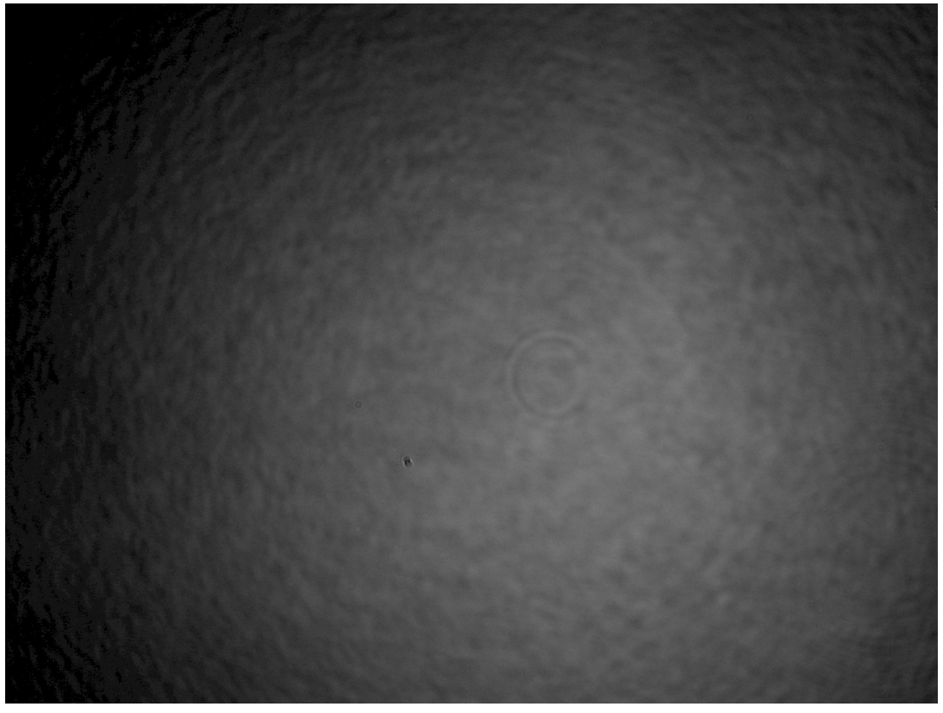

Figure 2: Intensity profile of the initial laser beam

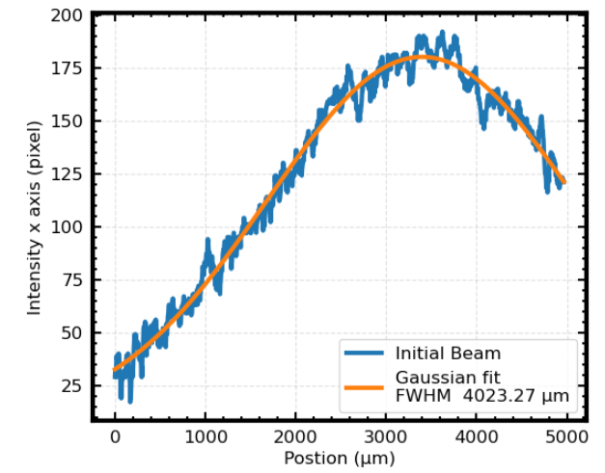 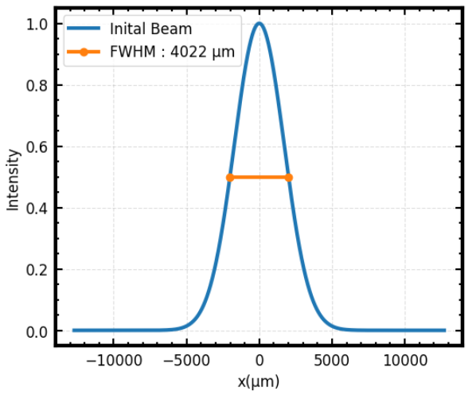

Figure 3: Measured (left) and simulated (right) initial laser beam intensity profile

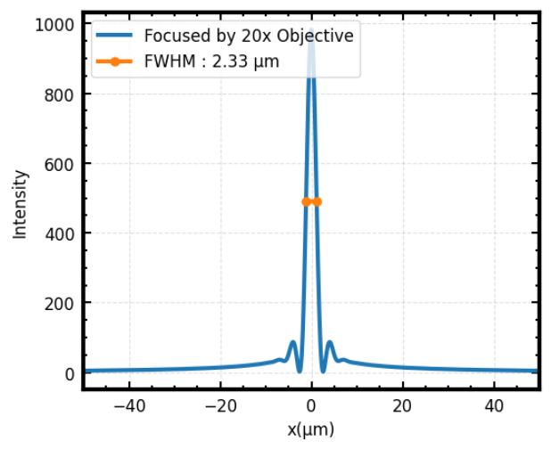

Figure 4: Simulated laser beam intensity profile under lens #1 (20x microscope objective). Each pixel is 3.45 µm by 3.45 µm, thus it was not possible to resolve the beam size at focus.

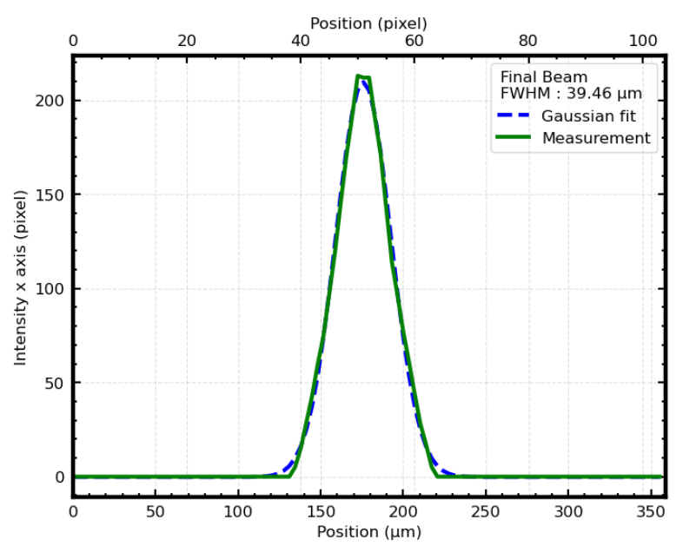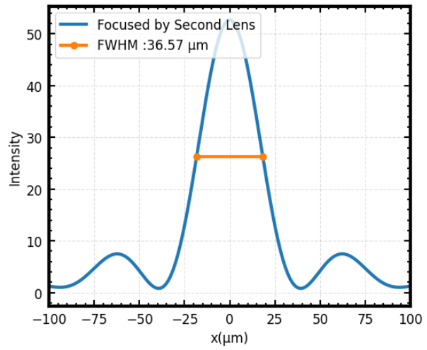

Figure 5: Measured (left) and simulated (right) laser beam intensity profile on the camera, final beam.

# Comments

We see good agreement between the measured and simulated beam profiles as shown in Figure 5. We suspect that the resolution power of the camera causes the mismatch, but we will do further work to understand the reason.

## References

[1] P. Y. Amnon Yariv, *Optical Waves in Crystals: Propagation and Control of Laser Radiation* (Wiley, New York, 1984).

[2] *Diffractio Documentation: Rayleigh-Sommerfeld (RS) Integral*, https://www.ptonline.com/articles/how-to-get-better-mfi-results.

[3] F. Shen and A. Wang, *Fast-Fourier-Transform Based Numerical Integration Method for the Rayleigh-Sommerfeld Diffraction Formula*, Appl. Opt. **45**, 1102 (2006).